**MONITORING AND COMMUNICATION SYSTEM**

**- Phanindra V.V.D**

**- Shreyan Goswami**

**- Vansh Jain**

**Problem statement**

The monitoring and communication system allows users to connect to a single server and send messages, transfer files and screenshots to other users. The system is designed to facilitate easy access to all its features. There are two types of users for the system- Teachers and Students. Both users have almost the same functionalities. The teachers have the facility to request for a screenshot of a student’s workspace. The server forwards this request to the student workstation. The system takes a screenshots of the student’s workspace and sends it to the teacher without the knowledge of the student in question. This allows the teacher to monitor the students. Whenever a teacher connects to the server she will obtain a list of students connected to the server. A student on the other hand obtains a list of connected teachers. This list is updated dynamically. Users can choose the person to whom they want to send data with the restriction that a student cannot communicate with another student. All the interaction is done via GUI.

**1. Use-Case Diagram**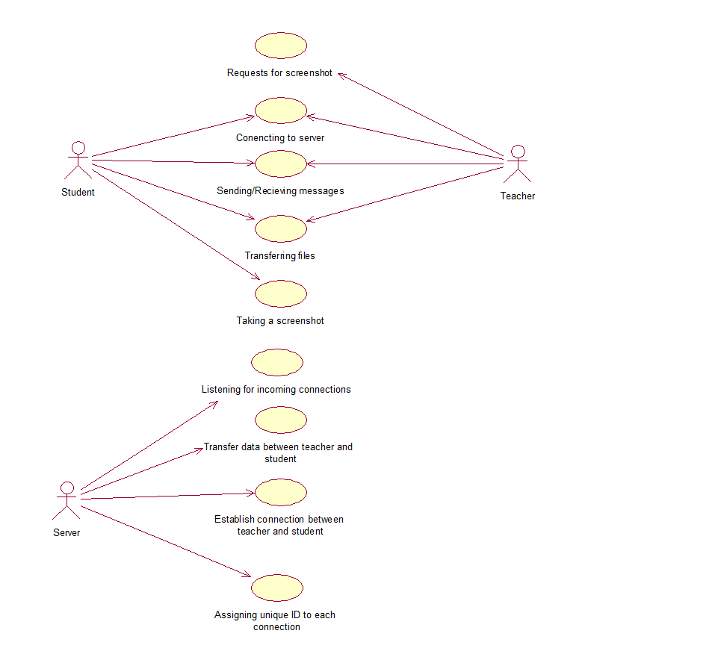

**2. Activity Diagram**

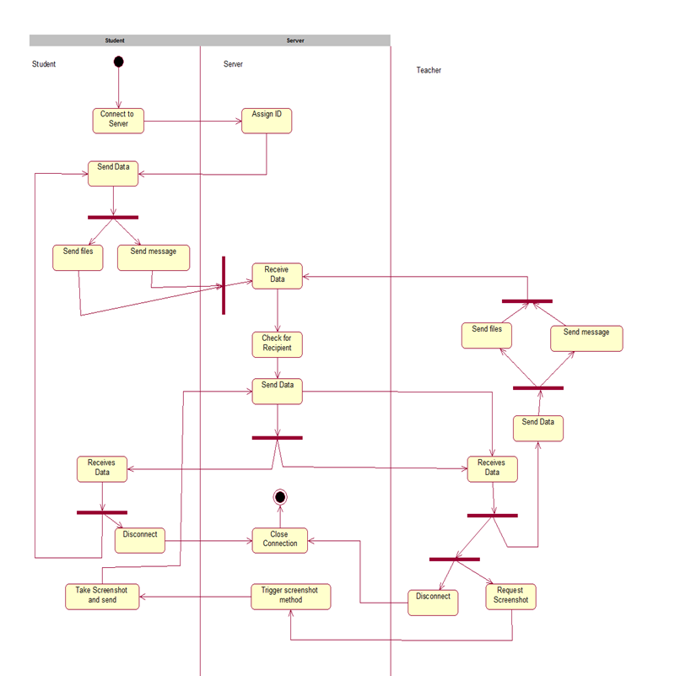

**3. Class Diagram**

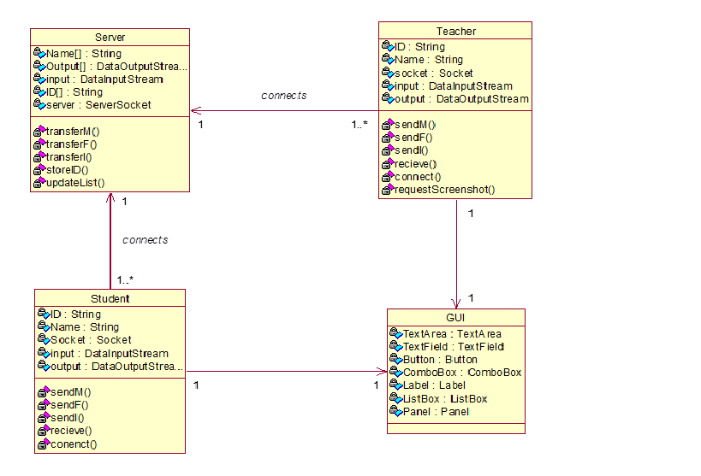

**4. Sequence Diagram**

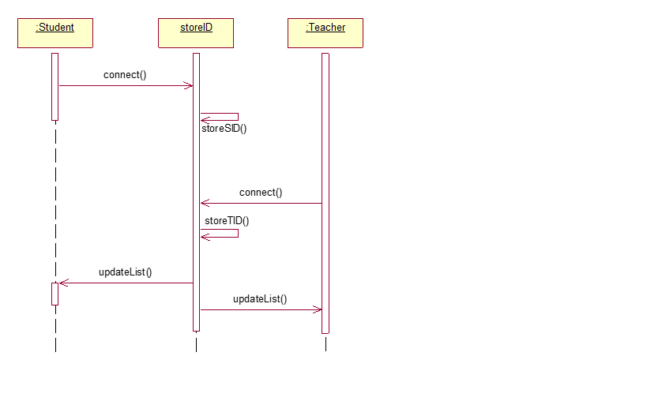

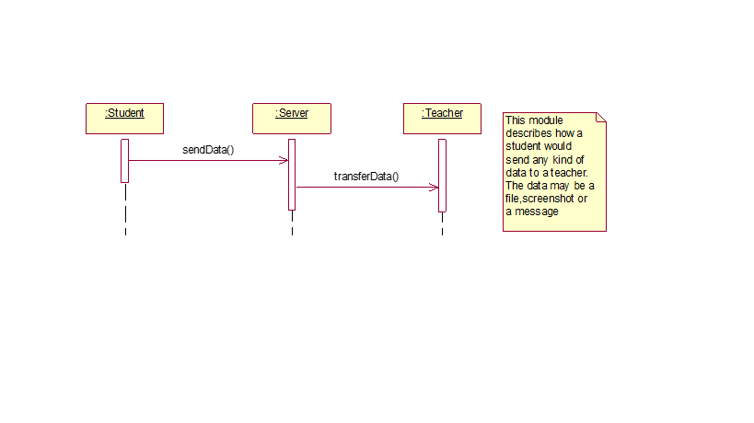

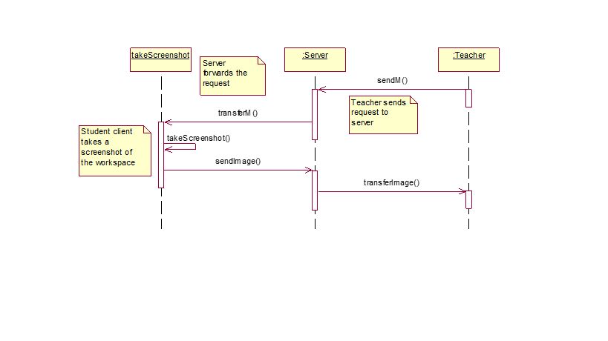**5. State-Chart Diagram**

